**ID Card System using RFID Technology**

Department of Electronics and Communication Engineering

*Panimalar Engineering College, poonamallee, chennai-600123*

*Team Members. a)Praveen T, b) Prashanth C, c)Pradheesh J, d)Mageshwaran P*

**TABLE OF THE CONTENTS**

|  |  |
| --- | --- |
| No. | TOPICS |
|  | INTRODUCTION |
|  | ORIGIN OF RFID. |
|  | INVENTIONS |
|  | INVENTOR OF RFID |
|  | RFID TAG ORIGIN |
|  | ENGINEERING BEHIND RFID |
|  | What's INSIDE A RFID TAG |
|  | ABOUT ESP8266 |
|  | ID Card Management Using RFID |
|  | CONCLUSION |

**ABSTRACT.** This project presents an innovative solution for ID card sensing using Radio Frequency Identification (RFID) technology integrated with an ESP32 microcontroller. The system aims to enhance security and streamline access control by leveraging RFID tags embedded in ID cards and the versatile capabilities of the ESP32 board. The ESP32 processes RFID data in real-time, offering a compact and efficient method for verifying and managing access permissions. This setup not only provides a secure authentication mechanism but also supports scalability and integration with various applications, including office security systems and personal identification. The integration of RFID with ESP32 enhances system responsiveness and reliability, making it a robust solution for modern access control requirements.

# I. INTRODUCTION

RFID (Radio Frequency Identification) technology has become increasingly popular in ID management due to its ability to streamline identification processes and enhance security. Unlike traditional methods that rely on visual inspection or manual data entry, RFID uses electromagnetic fields to automatically identify, and track tags attached to objects, such as ID cards. This capability makes RFID an ideal solution for environments where quick and accurate identification is critical, such as in schools, offices, and secure facilities. By integrating RFID into ID management systems, organizations can improve efficiency, reduce human error, and enhance overall security, making it a preferred choice for modern identification solutions.

# II. ORIGIN OF RFID

In 1948, Harry Stockman, an American physicist, theorized that radio signals could be used to wirelessly transmit data and track objects. The concept of Radio-Frequency Identification (RFID) technology dates to World War II when researchers began experimenting with radar-based identification systems to detect aircraft. The first practical RFID systems were developed in the 1960s. One notable development was in 1969 by American engineer, Mario Cardullo, who is credited with inventing the first passive RFID tag with a unique serial number. This technology has evolved significantly over the decades, with modern applications spanning from inventory management to contactless payment systems.

**III. INVENTIONS**

RFID (Radio Frequency Identification) technology has led to numerous inventions and innovations across a wide range of industries.

* Supply Chain Management and Inventory Tracking
* Contactless Payment Systems
* Transportation and Toll Collection
* Access Control and Security Systems

# IV. INVENTOR OF RFID

**Charles Alfred Dodgson's Walton** (December 11, 1921 – November 6, 2011) is best known as the first patent holder for the RFID (radio frequency identification) device. Many individuals contributed to the invention of the RFID, but Walton was awarded ten patents in all for various RFID-related devices, including his key 1973 design for a "Portable radio frequency emitting identifier". This patent was awarded in 1983 and was the first to bear the acronym "RFID".



**Figure 1. Charles Alfred Dodgson's Walton**

# V. RFID TAG ORIGIN

The origins of Radio-Frequency Identification (RFID) technology can be traced back to World War II. During the war, researchers were exploring ways to distinguish between friendly and enemy aircraft, leading to the development of the first radar-based identification systems. These early systems laid the groundwork for what would eventually become RFID technology.

In the 1940s, British scientists developed a system called "Identify Friend or Foe" (IFF), which used radio waves to identify allied aircraft, preventing friendly fire incidents. Although not RFID in the modern sense, IFF was a precursor to the concept of using radio frequencies for identification.

The first significant leap towards modern RFID occurred in the 1960s. In 1963, Los Alamos National Laboratory experimented with RFID technology for tracking nuclear materials. This period also saw the emergence of various patents related to RFID technology.

A major breakthrough came in 1969 when American engineer Mario Cardullo developed the first passive RFID tag. Cardullo's invention was a milestone, as it introduced the concept of storing a unique serial number on the tag, which could be read remotely using radio waves. This innovation laid the foundation for many of the applications we see today, from inventory management to access control systems.

In 1973, Charles Walton received a patent for an RFID system used to unlock doors without a key, one of the earliest commercial uses of RFID. This invention paved the way for the widespread adoption of RFID in security and access control.

Throughout the 1980s and 1990s, RFID technology continued to evolve, becoming more sophisticated and affordable. The development of Ultra-High Frequency (UHF) RFID in the 1990s allowed for longer read ranges and faster data transfer, making RFID practical for large-scale applications like supply chain management.

Today, RFID is ubiquitous, with applications spanning industries such as retail, healthcare, transportation, and beyond. From tracking goods in a warehouse to enabling contactless payments, RFID technology has become an integral part of modern life, thanks to its origins and decades of innovation.



**Figure 2.** Mario Cardullo

# VI. ENGINEERING BEHIND RFID

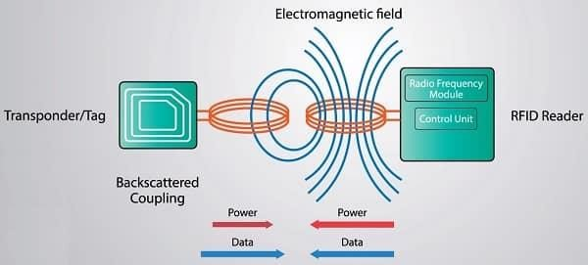

Construction:

*RFID Tag:*

* Microchip: Stores data, such as a unique identifier.
* Antenna: Transmits and receives radio signals.
* Substrate: Holds the microchip and antenna, often made of plastic or paper.
* Power Source:

Passive Tags: No internal battery; powered by the reader’s signal. Active Tags: Battery-powered, allowing longer read distances.

* Semi-Passive Tags: Battery-powered but rely on the reader for communication.

*RFID Reader:*

* Antenna: Emits radio waves and receives signals from tags.
* Transceiver: Generates and captures radio signals.
* Processor: Decodes data from the tags and sends it to the backend system.

*Backend System:*

* Middleware: Manages communication between readers and databases.
* Database: Stores RFID data for tracking and analysis.
* User Interface: Provides tools for monitoring and managing RFID data.

Working:

*Tag Activation:*

The RFID reader emits a radio frequency signal.

The tag’s antenna captures this signal, powering the tag (for passive tags) or communicating data (for active tags).

*Data Transmission:*

The tag’s microchip modulates the radio signal to encode data (e.g., a unique ID). The reader’s antenna receives and decodes this signal.

*Data Processing:*

The reader sends the decoded data to the backend system.

The backend system processes and stores this data in a database. *Application Integration:*

The data is used for various applications like inventory management, access control, or asset tracking, based on predefined rules and requirements.

# VII. WHAT’s INSIDE A RFID TAG

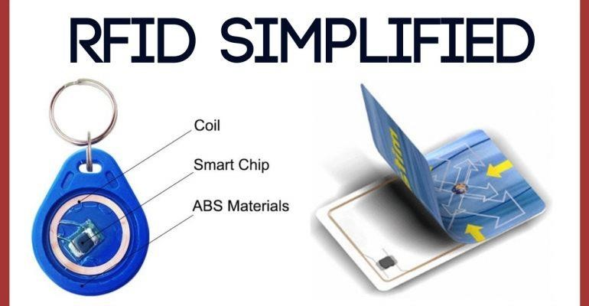

RFID tag is a small electronic device for non-contact data exchange through radio waves. It is mainly composed of three parts: **chip, antenna, and package**. As the core component of an RFID tag, **the chip stores unique identification information and handles communication with the reader.**

**ABS (Acrylonitrile Butadiene Styrene)** is used in RFID tags for its durability, impact resistance, and versatility. It withstands rough handling and harsh environmental conditions, maintains performance across a wide temperature range, and resists many chemicals. Additionally, ABS is easy to mold and finish, allowing for custom designs and clear printing. These properties make ABS an ideal choice for robust and reliable RFID tags.

In passive RFID tags, which lack an internal power source, the signal is produced through a process known as **inductive coupling**. When a passive tag comes into range of an RFID reader, the reader emits an electromagnetic radio frequency (RF) signal, creating an electromagnetic field. The tag’s antenna captures this RF energy and converts it into electrical power to briefly energize the tag’s microchip. The microchip then modulates the electromagnetic field by varying the load on the antenna, creating a response signal that encodes the tag’s data. This modulated signal is sent back to the RFID reader, which decodes the information.

Essentially, the passive tag uses the energy from the reader’s signal to power its chip and transmit data, even though it doesn’t have its own power supply.

## VIII. ABOUT ESP8266

The ESP8266 is a highly popular Wi-Fi module microcontroller developed by Espressif Systems, known for its affordability and versatility in IoT (Internet of Things) projects. It integrates Wi-Fi connectivity, allowing devices to connect to wireless networks and communicate over the internet without additional components. The module features a 32-bit RISC CPU, typically running at 80 MHz, with the capability to be overclocked to 160 MHz. It includes 32 KB of instruction RAM and 80 KB of data RAM, along with flash memory that ranges from 512 KB to 16 MB, depending on the variant. The ESP8266 offers a variety of GPIO pins and supports communication protocols such as UART, SPI, I2C, and PWM. Its low power consumption in sleep modes makes it ideal for battery-operated applications. The module can be programmed using environments like the Arduino IDE or Espressif’s ESP-IDF, making it accessible to both beginners and experienced developers. Common uses include IoT devices, home automation, and networking projects, where its combination of Wi-Fi capability, processing power, and ease of use make it a favored choice.

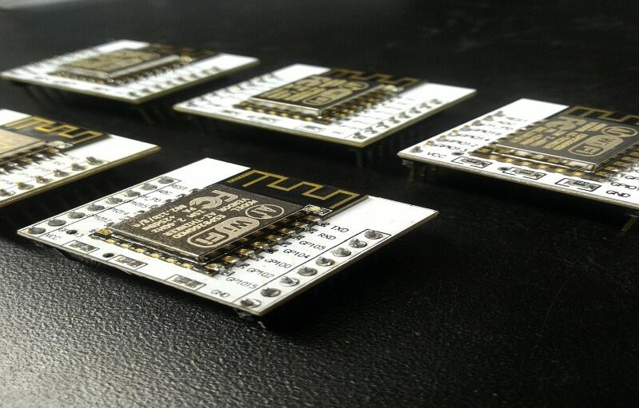

**IX. ID Card Management Using RFID**

How It Works:

Components:

* RFID Tag: Embedded in the ID card, it contains a microchip and antenna that store and transmit unique ID data.
* RFID Reader: Scans the RFID tag to read the data.
* ESP8266 Module: A Wi-Fi module that connects the RFID reader to the internet.

Process:

* Tag Detection: When an ID card is scanned, the RFID reader reads the tag’s data.
* Data Transmission: The reader sends this data to the ESP8266 module.
* Wi-Fi Connection: The ESP8266 transmits the data over Wi-Fi to a server or web application.

Integrating with Sheet:

Setup:

* Connect Components: Connect the RFID reader to the ESP8266. Configure the ESP8266 to connect to your Wi-Fi network and send data to a server.
* Web Application: Set up a web application or server that receives the data from the ESP8266.

Execution:

* Data Logging: The Excel file records all data from ID card scans, such as access times and card numbers. • Reporting: Use Excel Sheet to create reports or dashboards that show ID card usage and other metrics.

# X. CONCLUSION

The integration of RFID technology with the ESP8266 module and Excel provides a robust and efficient solution for ID card management. By leveraging RFID tags for secure identification, the ESP8266 for seamless Wi-Fi communication, and Excel for data logging and reporting, this project streamlines the process of tracking and managing ID card usage. The result is an automated, real time system that enhances security, simplifies data management, and provides valuable insights through easily accessible reports and dashboards.